**SYLLABUS**

**COURSE NAME: COMPOSITION AND MODERN ENGLISH II**

**CODE: ENG 1102**

**WORTH: 3 credits**

**PREREQUISITE: ENG 1101 with C**

**INSTRUCTOR:** **Huong Tran**

[Huongtran038@gmail.com](mailto:Huongtran038@gmail.com), [Thuong@troy.edu](mailto:Thuong@troy.edu)

**OFFICE HOUR:** By appointment

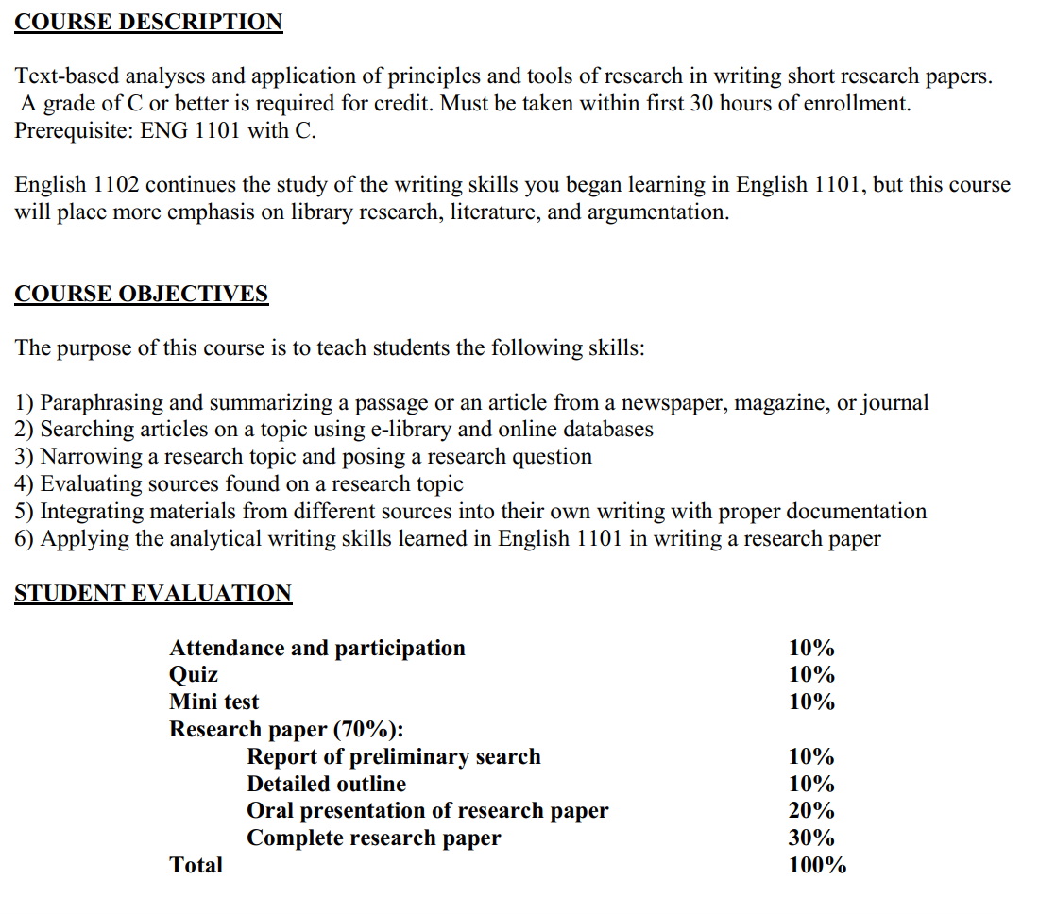

|  |  |  |
| --- | --- | --- |
| **Sessions** | **Contents** | **Materials** |
| 1 | **Course introduction + Grammar review**  Effective sentence  Word choice | The writers’ reference  The Bedford guide  Handout |
| 2 | **Introduction to research writing**  Types  Format  Process  Sample paper  Manage the research project  **Final assignment release**  **Quiz (10%)** | The writers’ reference  The Bedford guide  Handout |
| 3 | **STEP 1: Choose a subject and narrow it to a topic**  Choosing a topic, narrowing down a topic  Determining your research question  Researching: Think like a researcher | The writers’ reference  The Bedford guide  Handout |
| 4 | **STEP 2.1: Find information. Doing preliminary search and evaluate sources**  Search effieciently  E-library session: choosing databases, searching for books and articles  Select sources  Assess web source | The writers’ reference  The Bedford guide  Handout |
| 5 | **STEP 2.2 Managing information, taking notes responibly**  Working bibliography  Annotated bibliography  Track of source materials  Avoid plagiarism: quoting, summarizing, paraphrasing, synthesizing  Revise your topic and research questions  **Mini test (10%)** | The writers’ reference  The Bedford guide  Handout |
| 6 | **STEP 3: State your thesis**  APA papers: Sample  State your thesis  Supporting a thesis  Integrating sources | The writers’ reference  The Bedford guide  Handout |
| 7 | **Due: Report of your preliminary search (10%)**  **STEP 4: Make an outline + Writing referencing**  APA, MLA, CMS  Formating an APA research paper  Statistics in APA  Documenting sources  Signal phrases and verbs  Indentifying signal phrases in a journal article | The writers’ reference  The Bedford guide  Handout |
| 8 | **Due: Report of research paper outline (10%)**  **STEP 5: Organize your notes according to your outline**  Revise the outline | The writers’ reference  The Bedford guide  Handout |
| 9 | **STEP 6: Write your first draft**  Writing introduction | The writers’ reference  The Bedford guide  Handout |
| 10 | **STEP 6 (cont’): Write your first draft**  Writing discussion and findings  **Quiz (10%)** | The writers’ reference  The Bedford guide  Handout |
| 11 | **STEP 6 (cont’): Write your first draft**  Writing recommendations and a conclusion | The writers’ reference  The Bedford guide  Handout |
| 12 | **STEP 6 (cont’): Write your first draft**  Writing abstract + revise reference list | The writers’ reference  The Bedford guide  Handout |
| 13 | **STEP 7: Revise and edit your paper (peer review)**  **Oral presentation (20%)** | The writers’ reference  The Bedford guide  Handout |
| 14 | **STEP 8: Type final paper**  **Complete research paper with printouts of all documented sources**  Oral presentation | The writers’ reference  The Bedford guide  Handout |
| 15 | **FINAL ASSIGNMENT SUBMISSION (30%)**  Oral presentation | The writers’ reference  The Bedford guide  Handout |

**YOUR FINAL ASSIGNMENT**

You are required to write a research paper of 1,500 words on a topic of your choice. Use a minimum of seven sources, some of which are books and some of which are periodicals (journals/magazines). At least two of your sources must come from articles (or books) published during the past three years. Write the research paper in the form required (APA). 